Virtual Event Management Platform

Department of Computer Information Systems

College of Computer Science & Information Technology

Group C

**Use case diagram:**

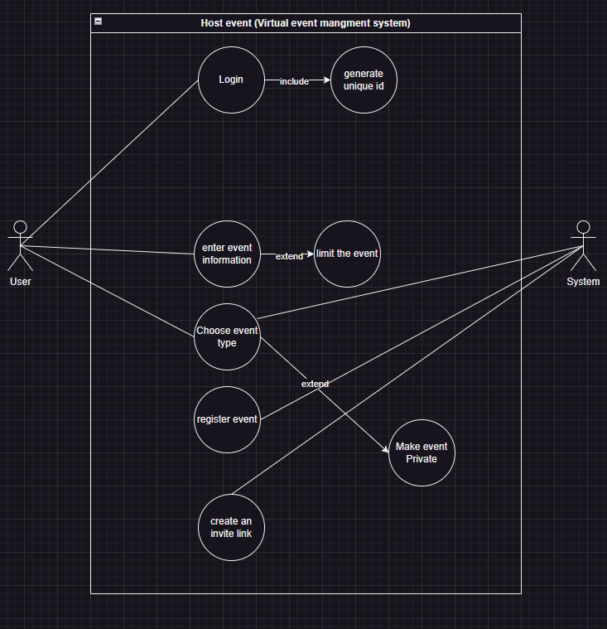

**One sequence diagram:** 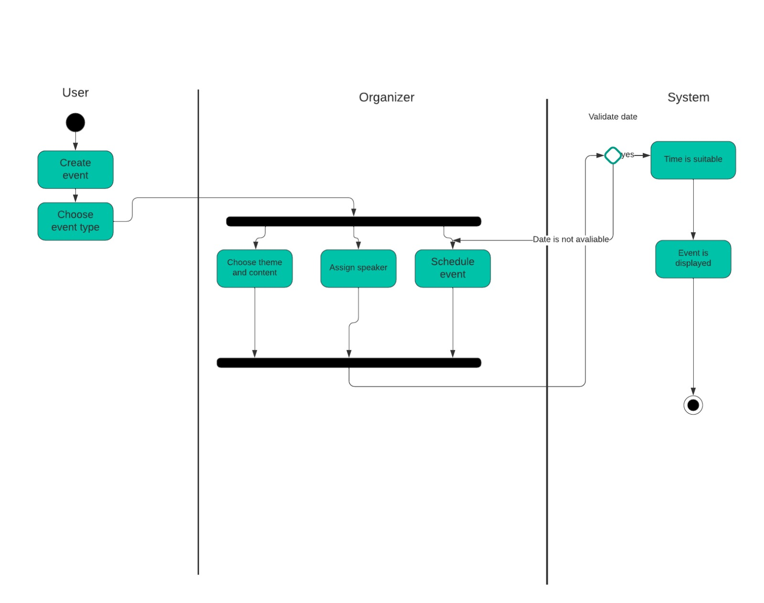

**One activity diagram:**

